Muscle Stimulation with Digitally Tunable Stimulus

Mashhour Bani Amer*, Rami Oweis
Biomedical Engineering Department
Faculty of Engineering
Jordan University of Science and Technology, 22110 Irbid, Jordan

Abstract

New design of a muscle stimulator with fully programmable output signal is proposed. The main advantages of this stimulator are that it is flexible, cheap, programmable, interface able with personal computers (PC), and reliable one. The experimental results prove that the designed stimulator has a very good performance and suitable for clinical applications.

1. Introduction

The muscle stimulator has been widely used in physical therapy specially for patients with hemiplegia and paralysis [1-4]. During the past 20 years, implantable and digital stimulators have offered new possibilities for the treatment of many organ failures [5]. However, effective control of hemiplegia and paralysis still remains a problem when attempting a complete stimulation of nerves and muscles [6, 7]. This is because the majority of commercially available stimulators lack significant feature which is the wide range of programmable output parameters. This is why, in this paper, attempt has been done to develop a new programmable stimulator with digitally tunable output signal.

2. System Description

The designed system is built up of programmable constant current source, data acquisition card, PC and stimulating electrodes (Fig.1).

Programmable constant current Source

Electrodes
Stimulating current
Analog input channel

PC
Data Acquisition Card
Digital Control

D₀ - D₇

Fig. 1 Simplified block diagram of the designed programmable muscle stimulator

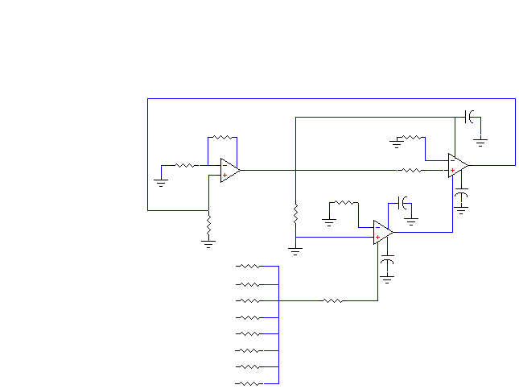

The programmable current source (Fig.2) provides the required stimulation DC current having amplitudes in the range of 0 to 100 mA with a maximum resolution of 0.3 mA. The programmable stimulator comprises of voltage-mode operational amplifiers (op-amps), two transductance op-amps (OTA₁ and OTA₂). The bias current of transcodunctance op-amp OTA1 is controlled by digital-code available at D₀ to D₇. This digital code is controllable by personal computer. The value of I_{ABC1} controls the amount of bias current I_{ABC2} which in turn controls the output current I_{o}. Of course, the op-amps OTA1 and OTA2 serve as a resistor with a value R=9.09/I_{o}. Thus, changing the value of I_{o} by digital code D₀-D₇ will result in a digital tuning of this resistor.
1KΩ
1KΩ
+V_{CC}
°
-V_{CC}
I_{s}
R₁
10KΩ
D₀
D₁
D₂
D₃
D₄
D₅
D₆
D₇
R₀
R₁
R₂
R₃
R₄
R₅
R₆
R₇
R_{X}
I_{ABC1}
10KΩ
10KΩ
0.01μF
0.01μF
10KΩ
0.01μF
0.01μF
I_{ABC2}
R_{Y}

OTA₁
OTA₂

Fig. 1 The programmable current source

This digitally tunable resistance with the voltage-mode op-amp circuit forms a current source with programmable amplitude. The designed tunable resistor is experimentally verified and a sample of the obtained results is presented in Table 1.

Table.1: A sample of test results of a digital tunable resistance
D₇ | D₆ | D₄ | D₅ | D₃ | D₂ | D₁ | D₀ | Decimal Number | I_{ABC2} [mA] | I_{ABC1}  [mA] | I_{o} [mA] | R[KΩ]
0 | 0 | 0 | 0 | 0 | 0 | 0 | 0 | 0 | 0.90 | 0.830 | 0.8 | 10.9
0 | 0 | 0 | 0 | 1 | 1 | 1 | 1 | 15 | 0.91 | 0.854 | 0.9 | 9.57
1 | 1 | 0 | 0 | 0 | 0 | 0 | 0 | 192 | 1.28 | 1.195 | 1.3 | 6.52
1 | 1 | 0 | 0 | 1 | 1 | 0 | 0 | 204 | 1.30 | 1.208 | 1.3 | 6.73
1 | 1 | 1 | 1 | 0 | 0 | 0 | 0 | 240 | 1.36 | 1.270 | 1.4 | 6.40
1 | 1 | 1 | 1 | 1 | 1 | 1 | 1 | 255 | 1.38 | 1.290 | 1.4 | 6.30

From this table it can be concluded that changing the binary code at D₀-D₇ will cause a significant change of the tunable resistance R.

3. Conclusions

A DC current programmable muscle stimulator is presented. Of course, several fundamental experiments were carried out to evaluate the performance of the designed stimulator. The results indicate that the contractions of the stimulated muscles of different individuals are not the same. Furthermore, for a given person, the level of contractions of stimulated muscles are different at different times. This shows the difficulty in finding a control algorithm that could be used to any individual so as to realize the optimal stimulation of paralyzed muscle.
To facilitate the operation of the proposed stimulator a user friendly software has been developed. The developed software is written in C language. The change in amplitude and duration of the stimulated current is determined by the software and does not need any modification of the hardware.
At the present stage, the designed stimulator is used for educational purposes, and the experimental work is continued to improve the final design to be suitable for a clinical use.

References

[1] N. A. Dimitrova G. V. Dimitrov and O. Aniktin, Longitudinal variations of characteristic frequencies of skeletal muscle fiber potentials detected by a bipolar electrode or multi-electrode, Journal of Medical Engineering and Technology, vol. 25, No. 1, pp. 43-40, 2001.

[2] M. Sawan, F. Dural, M. Hassouna , and M. M. Elhilali, A new Transcutaneous fully programmable neural stimulator, The International Journal of Microcomputer Applications, vol.13, No. 3, pp.142-147, 1994.

[3] E. B Marsolais, and R. Kobetic, Functional walking in paralysed patients by means of electrical stimulations, Clinical Orthopedics , vol. 175, pp. 30-36, 1983.

[4] T. Belakan, H. J. Holaander, and G. Vossies, Microprocessor-controlled eight-channel stimulator with surface electrodes for FES of gait, proceedings of the 2nd Vienna International Workshop on Functional Electrostimulation, Vienna, Austria, pp. 71-73, 1986.

[5] D. Popovic, R. B Stein, K. Jovanovic, R. Koston and A. Armstrong, Sensory never recording for a closed loop control to restore anther function, IEEE Transactions on Biomedical Engineering, vol. 40, pp.1024 –1031, 1993.

[6] I. M. Vasilenic, and D. B Popovic, Programmable electronic stimulator for FES system, IEEE Transaction on Rehabilitation Engineering , vol. 4 , pp. 234-239.

[7] Y. L. Cleem , Y. C. Li, T. S. Kuorneed J. S. Lai, The Development of closed-Loop controlled function electrical stimulation (FES) in gait training, Journal of Medical Engineering and Technology, vol. 25, No. 2 , pp. 41-48, 2001.

